Vegetable Korma

10 Servings Prep-time 15 minutes Cook-time 25 minutes
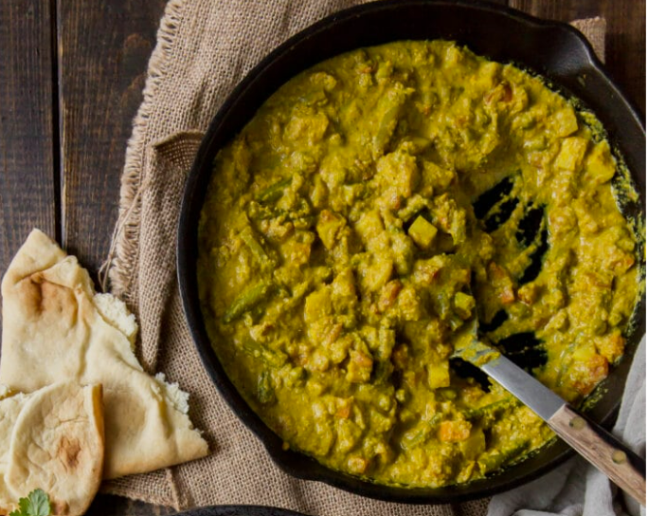
Ingredients

For the sauce
2.5 medium yellow onion – peeled and halved
7.5 cloves garlic - peeled
2.5 1-inch piece ginger root, roughly chopped
2.5 jalapeno pepper – stemmed and seeded
0.75 cup raw cashews

For the Korma
2.5 tablespoon vegetable oil
5 teaspoons curry powder
2.5 teaspoon ground turmeric
2.5 teaspoon garam masala
1.25 teaspoon cinnamon
1.25 teaspoon coriander
1.25 teaspoon salt
1.25 teaspoon ground black pepper
0.25 teaspoon ground cardamom
5 small tomatoes - diced
1.25 cup canned - unsweetened full-fat coconut milk
2 cup plain yoghurt/ vegan alternative(coconut milk)
3.75 teaspoons brown sugar
2.5 medium potato - peeled and diced
2.5 cup frozen peas and carrot mix
2.5 cup chopped fresh green beans

Instructions

- Place the onion, garlic, ginger, jalapeno, and cashews in the bowl of a blender along with 1/2 cup of water. Process until pureed.
- Heat the vegetable oil in a large saute pan set over medium heat. While the oil heats, measure out all of the spices (the curry powder through cardamom) and place in a small bowl.
- Pour the pureed sauce mixture into the hot pan, using caution to avoid splatters. Stir in the pre-measured spices and allow to cook for 2 to 3 minutes, until fragrant.
- Add the tomato, coconut milk, yogurt, brown sugar, potato, peas-and-carrots, and green beans. Stir well, cover the pan, and allow to simmer on medium heat for 10 minutes.
- Uncover and cook a further 5 to 10 minutes, until the potatoes are tender. Serve with cooked basmati rice and naan bread.

